Student Performance Analysis

Prepared by

Ibrahim Omar Alghamdi

Feel Free To Check My LinkedIn Or GitHub Pages (link in picture) :

[](https://github.com/ibrahim9848?tab=repositories)

[](https://www.linkedin.com/in/ibrahim-alghamdi-6b35a921b/)

Or feel free to reach out:



IBRAHIM.OMAR.ALGHAMDI@gmail.com

+966552232009

Table of Contents

Executive Summary: 3

Objective: 3

Dataset Overview: 4

Key Findings and Insights: 4

Overall Performance Patterns 4

Gender Differences 5

Parental Education Impact 5

Lunch Type as a Socio-Economic Indicator 6

Test Preparation Course Effectiveness 6

Key Recommendations 7

Conclusion 7

# Executive Summary:

This report presents an analysis of the StudentsPerformance dataset to identify the key factors that influence student academic outcomes. The dataset includes 1,000 students, covering demographic, socio-economic, and preparatory variables.

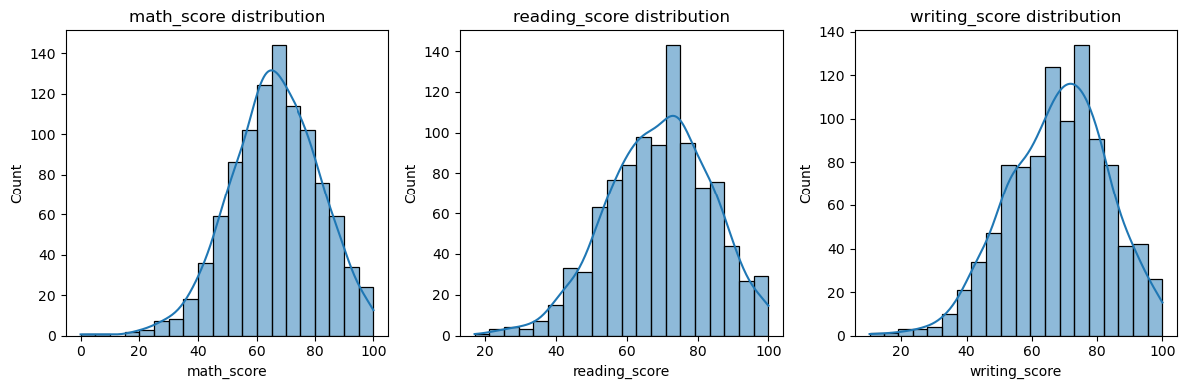Through data cleaning and exploratory data analysis (EDA), the study reveals that test preparation, parental education, and lunch type are the strongest predictors of student performance. Female students generally outperform males in reading and writing, while males perform slightly better in math. The report concludes with actionable recommendations to improve overall student performance and equity.

Figure 1: Overall distribution of scores across math, reading, and writing (histograms).

# Objective:

The objective of this analysis is to uncover insights into how various socio-economic and preparatory factors affect students’ academic results. The goal is to guide decision-makers on where to focus resources and interventions to enhance academic outcomes across diverse student groups.

# Dataset Overview:

* Dataset size: 1,000 records
* Attributes: 8 columns covering demographic, parental, and academic information
* Data fields: Gender, Race/Ethnicity, Parental Education, Lunch Type, Test Preparation Course, Math Score, Reading Score, Writing Score
* Data quality: Clean, complete, and validated — no missing or invalid values

The data allows for comprehensive evaluation of performance trends and relationships across key variables.

# Key Findings and Insights:

## Overall Performance Patterns

* Math, reading, and writing scores are strongly correlated, indicating consistent student performance across subjects.
* Reading and writing show the highest correlation, suggesting that verbal and comprehension abilities are closely linked.

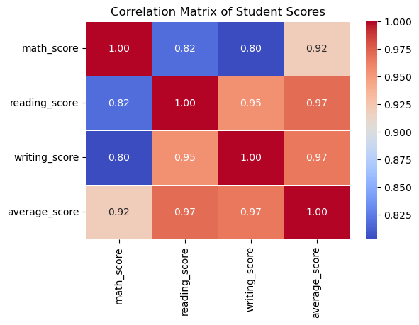

Figure 2: Correlation heatmap showing relationships between math, reading, and writing scores.

## Gender Differences

* Males slightly outperform females in math, while females outperform males in reading and writing.
* 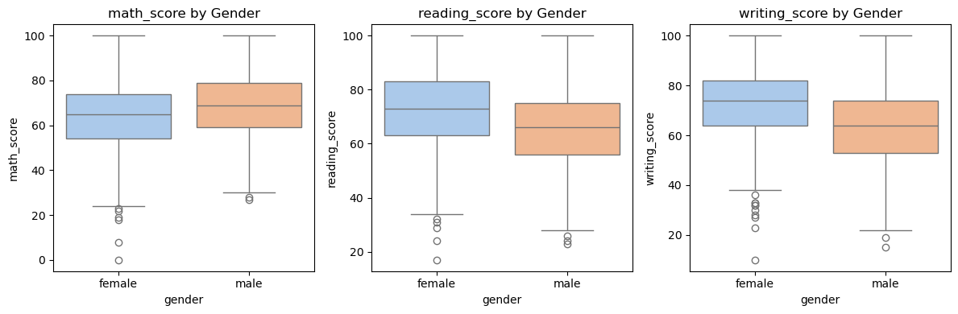This suggests distinct learning strengths across genders that could inform subject-specific support strategies.

Figure 3: Boxplots comparing gender performance across math, reading, and writing.

## Parental Education Impact

* A strong positive relationship exists between parental education and student performance.
* Students whose parents hold bachelor’s or master’s degrees achieve the highest average scores.
* 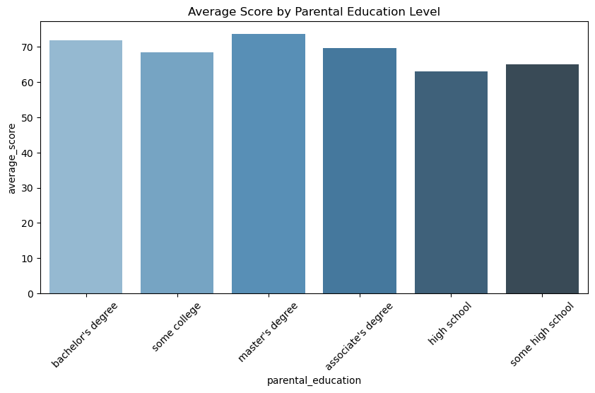It indicates that academic background at home significantly influences student achievement.

Figure 4: Barplot of average scores by parental education level

## Lunch Type as a Socio-Economic Indicator

* 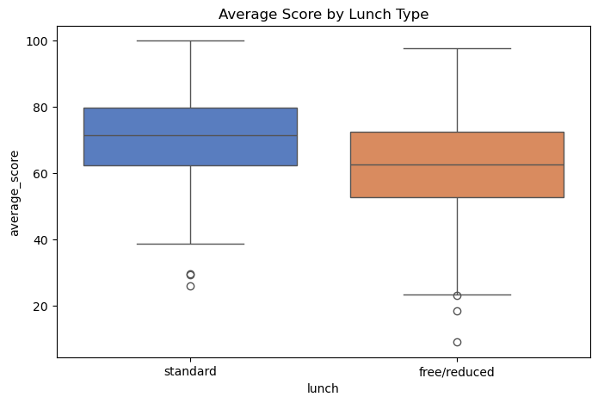Students with standard lunch outperform those receiving free/reduced lunch, suggesting that socio-economic conditions influence educational outcomes.

Figure 5: Boxplot of average scores by lunch type.

## Test Preparation Course Effectiveness

* Students who completed the test preparation course consistently achieved higher scores across all subjects.
* A graph of a graph

  AI-generated content may be incorrect.This confirms the course’s effectiveness and supports scaling similar preparatory programs.

Figure 6: Boxplot of average scores by test preparation course completion.

# Key Recommendations

1. Expand Test Preparation Access  
   Provide greater access to test preparation programs, particularly for lower-income students, as this intervention shows the most measurable improvement.
2. Enhance Parental Engagement  
   Create initiatives that encourage parental involvement, especially for families with lower educational backgrounds.
3. Address Socio-Economic Gaps  
   Offer nutritional and financial support programs for students on free/reduced lunch to reduce disparities in opportunity and performance.
4. Balance Gender-Specific Learning Support  
   Continue promoting STEM participation among female students while improving literacy-focused engagement for male students.

# Conclusion

The findings show that student success depends on both preparation and environment.  
Test preparation, parental education, and socio-economic conditions are key drivers of academic outcomes.

Investing in these areas—especially test prep expansion and targeted support for underprivileged groups—can significantly elevate student performance and close existing achievement gaps.